Section 2-1 Inductive Reasoning and Conjecture

SOL: None

Objectives:
Make conjectures based on inductive reasoning
Find counterexamples

Vocabulary:
Conjecture – an educated guess based on known information
Inductive reasoning – reasoning that uses a number of specific examples to arrive at a plausible generalization or prediction
Counterexample – a false example

Key Concept:

5 Minute Review:
1. Find the value of x if R is between Q and T, QR = 3x + 5, RT = 4x – 9, and QT = 17.

2. Find the distance between A(–3, 7) and B(1, 4).

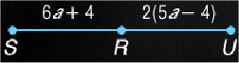
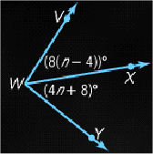
3. Find m∠C if ∠C and ∠D are supplementary, m∠C = 3y – 5, and m∠D = 8y + 20.
__
4. Find SR if R is the midpoint of SU.

5. Find n if WX bisects ∠VWY.

___
6. Find the coordinates of the midpoint of MN if M(3, 6) and N(9, -4).

Example 1: Make a conjecture about the next number based on the pattern: 2, 4, 12, 48, 240

Example 2: Make a conjecture about the next number based on the pattern: 1, ½, 1/9, 1/16, 1/25

Concept Summary:
Conjectures are based on observations and patterns
Counterexamples can be used to show that a conjecture is false

Preparation for Next Lesson: Read Section 2-2

Homework: pgs. 64-5: 4,5,11,13,15,17,21,23,29
Section 2-2 Logic

SOL: G.1 The student will construct and judge the validity of a logical argument consisting of a set of premises and a conclusion. This will include
b) translating a short verbal argument into symbolic form;
c) using Venn diagrams to represent set relationships; and

Objectives:
Determine truth values of conjunctions and disjunctions
Construct truth tables

Vocabulary:
And symbol (∧), Or symbol (∨), Not symbol (~)
Statement – any sentence that is either true or false, but not both
Truth value – the truth or falsity of a statement
Negation – has the opposite meaning of the statement, and the opposite truth value
Compound statement – two or more statements joined together
Conjunction – compound statement formed by joining 2 or more statements with “and”
Disjunction – compound statement formed by joining 2 or more statements with “or”

Key Concepts:
Negation: opposite statement; not p, or in symbols ~p
Conjunction: “and” two or more statements; p and q, or in symbols p ٨ q
Disjunction: “or” two or more statements; p or q, or in symbols p ٧ q

p | q | p٨q | p٧q | Truth Table  Examples | ~p | ~q | ~p٨~q | ~p٧~q
T | T | T | T | Truth Table  Examples | F | F | F | F
T | F | F | T | Truth Table  Examples | F | T | F | T
F | T | F | T | Truth Table  Examples | T | F | F | T
F | F | F | F | Truth Table  Examples | T | T | T | T
 |  | p and q | p or q | Truth Table  Examples | not p | not q | not p and not q | not p or not q

5 Minute Review:

Make a conjecture about the next item in the sequence.
1. 1, 4, 9, 16, 25 2. 2/3, 3/4, 4/5, 5/6, 6/7

Determine whether each conjecture is true or false. Give a counterexample for any false conjecture.

3. Given: ΔABC with m∠A = 60, m∠B = 60 and m∠C = 60. Conjecture: ΔABC is equilateral.

4. Given: ∠1 and ∠2 are supplementary angles. Conjecture: ∠1 and ∠2 are congruent.

5. Given: ΔRST is isosceles. Conjecture: RS ≅ ST

6. Make a conjecture about the next item in the sequence: 64, –32, 16, –8, 4.
a. -4 b. -2 c. 2 d. 4

Example 1: Use the following statements to write a compound statement for each conjunction. Then find its truth value.
p: June is the sixth month of the year.
q: A square has five sides.
r: A turtle is a bird.
a. p and r

b. ~q ∧ ~r

Example 2: Use the following statements to write a compound statement for each disjunction. Then find its truth value.
p: 6 is an even number.
q: A cow has 12 legs
r: A triangle has 3 sides.
a. p or r

b. ~q ∨ ~r

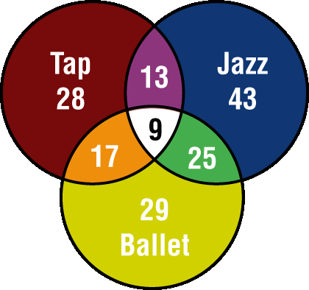
Venn Diagrams:

How many students are enrolled in all three classes?

How many students are enrolled in tap or ballet?

How many students are enrolled in jazz and ballet and not tap?

Truth Tables:

Construct a truth table for ~p ∨ q .

Concept Summary:
Negation of a statement has the opposite truth value of the original statement
Venn diagrams and truth tables can be used to determine the truth values of statements

Preparation for Next Lesson: reread Section 2-2; read Section 2-3

Homework: Day 1: pg 72-3: 15-17, 41-44, 45-47
Day 2: pg 72-3: 4-9, 10, 30, 31
Section 2-3 Conditional Statements

SOL: G.1 The student will construct and judge the validity of a logical argument consisting of a set of premises and a conclusion. This will include
a) Identify the converse, inverse, & contrapositive of a conditional statement;
b) Translating a short verbal argument into symbolic form;
c) Using Venn diagrams to represent set relationships; and
d) Using deductive reasoning, including the law of syllogism.

Objectives:
Analyze statements in if-then form
Write the converse, inverse and contrapositive of if-then statements

Vocabulary:
Implies symbol (→)
Conditional statement – statement written in if-then form
Hypothesis – phrase immediately following the word if in a conditional statement
Conclusion – phrase immediately following the word then in a conditional statement
Converse – exchanges the hypothesis and conclusion of the conditional statement
Inverse – negates both the hypothesis and conclusion of the conditional statement
Contrapositive – negates both the hypothesis and conclusion of the converse statement
Logically equivalent – multiple statements with the same truth values
Biconditional – conjunction of the conditional and its converse

Key Concepts:
If-then Statement: if <hypothesis - p>, then <conclusion - q> or p implies q or in symbols p → q
Related Conditionals:

Example: If two segments have the same measure, then they are congruent
 | Hypothesis | p | two segments have the same measure
 | Conclusion | q | they are congruent
Statement | Formed by | Symbols | Examples
Conditional | Given hypothesis and conclusion | p → q | If two segments have the same measure, then they are congruent
Converse | Exchanging the hypothesis and conclusion of the conditional | q → p | If two segments are congruent, then they have the same measure
Inverse | Negating both the hypothesis and conclusion of the conditional | ~p → ~q | If two segments do not have the same measure, then they are not congruent
Contrapositive | Negating both the hypothesis and conclusion of the converse | ~q → ~p | If two segments are not congruent, then they do not have the same measure

Biconditional: a biconditional statement is the conjunction of a conditional and its converse or in symbols
(p → q) ٨ (q → p) is written (p ↔ q) & read p if and only if q; All definitions are biconditional statements

5 Minute Review:
Use the following statements to write a compound statement for each and find its truth value.

p: 12 + –4 = 8 q: A right angle measures 90 degrees. r: A triangle has four sides.

1. p and r
2. q or r
3. ~p ∨ r
4. q ∧ ~r
5. ~p ∨ ~q
6. Given the following statements, which compound statement is false?
s: Triangles have three sides. q: 5 + 3 = 8
a. s ∨ q b. s ∧ q c. ~s ∧ ~q d. ~s ∨ q

Example 1: Identify the hypothesis and conclusion of the following statement.
If a polygon has 6 sides, then it is a hexagon.

H:

C:

Example 2: Identify the hypothesis and conclusion of the following statement.
Tamika will advance to the next level of play if she completes the maze in her computer game.

H:

C:

Example 3: Write the converse, inverse, and contrapositive of the statement All squares are rectangles.
Determine whether each statement is true or false.
If a statement is false, give a counterexample.

Conditional:

Converse:

Inverse:

Contrapositive:

Example 4: Write the converse, inverse, and contrapositive of the statement The sum of the measures of two complementary angles is 90°.
Determine whether each statement is true or false.
If a statement is false, give a counterexample.

Conditional:

Converse:

Inverse:

Contrapositive:

Concept Summary:
Conditional statements are written in if-then form
Form the converse, inverse and contrapositive of an if-then statement by using negations and by exchanging the hypothesis and conclusion

Homework: Day 1: pg 78, 5, 6, 8, 9, 13, 17, 21, 23, 25, 27
Day 2: pg 79-81, 43, 45, 53, 55, 57, (pg 81 1, 3)

Preparation for Next Lesson: study 2-1 to 2-2 for Quiz 2-1; read section 2.4
Section 2-4 Deductive Reasoning

SOL: G.1 The student will construct and judge the validity of a logical argument consisting of a set of premises and a conclusion. This will include
d) Using deductive reasoning, including the law of syllogism.

Objectives:
Use the Law of Detachment
Use the Law of Syllogism

Vocabulary:
Deductive Reasoning – the use of facts, definitions, or properties to reach logical conclusions

Key Concepts:
Law of Detachment: if p → q is true and p is true, then q is also true
or in symbols: [(p → q) ٨ p] → q
Law of Syllogism: if p → q and q → r are true, the p → r is also true
or in symbols: [(p → q) ٨ (q → r)] → (p → r)
Matrix Logic: Using a table to help solve problems

Five Minute Review:

Identify the hypothesis and conclusion of each statement.
- If 6x – 5 = 19, then x = 4 2. A polygon is a hexagon if it has six sides.

Write each statement in if-then form.
- Exercise makes you healthier.

- Squares have 4 sides.

- Adjacent angles share a common side.

- Which statement represents the inverse of the statement If ∠A is a right angle, then m∠A = 90°?
a. If ∠A is a right angle, then m∠A = 90° b. If m∠A = 90°, then ∠A is a right angle
c. If ∠A is not a right angle, then m∠A ≠ 90° d. If m∠A ≠ 90°, then ∠A is not a right angle
Example 1: Given WX ≅ UV; UV ≅ RT
Conclusion: WX ≅ RT

Example 2: PROM Use the Law of Syllogism to determine whether a valid conclusion can be reached from the following set of statements.
- If Salline attends the prom, she will go with Mark.
- Mark is a 17-year-old student.

Example 3: Use the Law of Syllogism to determine whether a
valid conclusion can be reached from each set of statements.
a. (1) If you ride a bus, then you attend school.
(2) If you ride a bus, then you go to work.

b. (1) If your alarm clock goes off in the morning, then you will get out of bed.
(2) You will eat breakfast, if you get out of bed.

Example 4: Determine whether statement (3) follows from statements (1) and (2) by the Law of Detachment or the Law of Syllogism. If it does, state which law was used. If it does not, write invalid.
(1) If Ling wants to participate in the wrestling competition, he will have to meet an extra three times a week to practice.
- If Ling adds anything extra to his weekly schedule, he cannot take karate lessons.
- If Ling wants to participate in the wrestling competition, he cannot take karate lessons.

Example 5: Determine whether statement (3) follows from statements (1) and (2) by the Law of Detachment of the Law of Syllogism. If it does, state which law was used. If it does not, write invalid.
- (1) If a children’s movie is playing on Saturday, Janine will take her little sister Jill to the movie.
(2) Janine always buys Jill popcorn at the movies.
(3) If a children’s movie is playing on Saturday, Jill will get popcorn.

b. (1) If a polygon is a triangle, then the sum of the interior angles is 180.
(2) Polygon GHI is a triangle.
(3) The sum of the interior angles of polygon GHI is 180.

Concept Summary:
The Law of Detachment and the Law of Syllogism (similar to the Transitive Property of Equality) can be used to determine the truth value of a compound statement.

Homework: pg 85: 13, 15, 16, 17, 21, 24, 26, 27

Preparation for Next Lesson: read Section 2-5
Section 2-5 Postulates and Paragraph Proofs

SOL: None.

Objectives:
Be able to use Matrix Logic
Identify and use basic postulates about points, lines and planes
Write paragraph proofs

Vocabulary:
Axiom – or a postulate, is a statement that describes a fundamental relationship between the basic terms of geometry
Postulate – accepted as true
Theorem – is a statement or conjecture that can be shown to be true
Proof – a logical argument in which each statement you make is supported by a statement that is accepted as true
Paragraph proof – (also known as an informal proof) a paragraph that explains why a conjecture for a given situation is true

Key Concepts:

Five Minute Review:

Determine whether the stated conclusion is valid based on the given information. If not, write invalid.
1. Given: ∠A and ∠B are supplementary. Conclusion: m∠A + m∠B = 180°.
2. Given: Polygon RSTU is a quadrilateral. Conclusion: Polygon RSTU is a square.
3. Given: ΔABC is isosceles. Conclusion: ΔABC has at least two congruent sides.
4. Given: ∠A and ∠B are congruent. Conclusion: ∠A and ∠B are vertical.
5. Given: m∠Y in ΔWXY is 90°. Conclusion: ΔWXY is a right triangle.
6. Which is a valid conclusion for the statement ∠R and ∠S are vertical angles?
a. m∠R + m∠S = 180° b. m∠R + m∠S = 90° c. ∠R and ∠S are adjacent d. ∠R ≅ ∠S
Matrix Logic Example: On a recent test you were given five different mineral samples to identify.
You were told that:
Sample C is brown Samples B and E are harder than glass Samples D and E are red
Using your knowledge of minerals (in the table below), solve the problem

Mineral | Color | Hardness (compared to glass)
Biolite | Brown or black | Softer
Halite | White | Softer
Hematite | Red | Softer
Feldspar | White, pink, or green | Harder
Jaspar | red | Harder

Sample | A | B | C | D | E
Biolite
Halite
Hematite
Feldspar
Jaspar

Examples: Determine whether the following statements are Always, Sometimes or Never True:

- If plane T contains EF and EF contains point G, then plane T contains point G.
- For XY, if X lies in plane Q and Y lies in plane R, then plane Q intersects plane R.
- GH contains three noncollinear points.
- Plane A and plane B intersect in one point.
- Point N lies in plane X and point R lies in plane Z. You can draw only one line that contains both points N and R.
- Two planes will always intersect a line.

Paragraph Proof Example 1:
Given AC intersecting CD, write a paragraph proof to show that A, C, and D determine a plane.
Given: AC intersects CD Prove: ACD is a plane

Paragraph Proof Example 2:
Given RT ≅ TY, S is the midpoint of RT and X is the midpoint of TY write a paragraph proof to show that ST ≅ TX
Given: RT ≅ TY, S is the midpoint of RT and X is the midpoint of TY Prove: ST ≅ TX

Concept Summary:
Use undefined terms, definitions, postulates and theorems to prove that statements and conjectures are true

Homework: pg 91: 3, 9, 16, 19, 28

Preparation for Next Lesson: read Section 2-6
Section 2-6 Algebraic Proof

SOL: None.

Objective:
Use algebra to write two-column proofs
Use properties of equality in geometry proofs

Vocabulary:
Deductive argument – a group of logical steps used to solve problems
Two-column proof – also known as a formal proof

Key Concepts:
Algebraic Properties:
Properties | of Equality for Real Numbers
Reflexive | For every a, a = a
Symmetric | For all numbers a and b, if a = b, then b = a
Transitive | For all numbers a, b, and c, if a = b and b = c, then a = c
Addition and Subtraction | For all numbers a, b, and c, if a = b, then a + c = b + c and a – c = b - c
Multiplication and Division | For all numbers a, b, and c, if a = b, then ac = bc and if c ≠ 0, a/c = b/c
Substitution | For all numbers a and b, if a = b, then a may be replaced by b in any equation or expression
Distributive | For all numbers a, b, and c, a(b + c) = ab + ac

Five Minute Review:

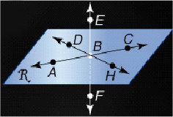
In the figure shown, A, C, and DH lie in plane R, and B is on AC.
State the postulate that can be used to show each statement is true.
1. A, B, and C are collinear.
2. AC lies in plane R .
3. A, H, and D are coplanar.
4. E and F are collinear.
5. DH intersects EF at point B.
6. Which statement is not supported by a postulate?
a. R and S are collinear b. M lies on LM c. P, X and Y must be collinear d. J, K and L are coplanar
Example 1: Solve 2(5 – 3a) – 4(a + 7) = 92

Given:
Prove:

Statements Reasons
1.
2.
3.
4.
5.
6.
7.

Example 2: If (10 – 8n) / 3 = -2, then n = 2

Given:
Prove:

Statements Reasons
1.
2.
3.
4.
5.
6.
7.

Formal Algebraic Proof Example:
SEA LIFE A starfish has five legs. If the length of leg 1 is 22 centimeters, and leg 1 is congruent to leg 2, and leg 2 is congruent to leg 3, prove that leg 3 has length 22 centimeters.

Given:
Prove:

Statements Reasons
1.
2.
3.
4.
5.

Concept Summary:
Algebraic properties of equality can be applied to the measures of segments and angles to prove statements

Homework: pg 97-8: 4-9, 15-18, 24, 25

Preparation for Next Lesson: read Section 2-7
Section 2-7 Proving Segment Relationships

SOL: None.

Objectives:
Write proofs involving segment addition
Write proofs involving segment congruence

Vocabulary:
No new vocabulary

Key Concepts:
Postulate 2.8: Ruler Postulate: The points on any line or line segment can be paired with real numbers so that, given any two points A and B on a line, A corresponds to zero and B corresponds to a positive real number.
Postulate 2.9: Segment Addition Postulate: If B is between A and C then AB + BC = AC and if AB + BC = AC, then B is between A and C.

Five Minute Review:

State the property that justifies each statement.
1. 2(LM + NO) = 2LM + 2NO
2. If m∠R = m∠S, then m∠R + m∠T = m∠S + m∠T.
3. If 2PQ = OQ, then PQ = ½OQ.
4. m∠Z = m∠Z
5. If BC = CD and CD = EF, then BC = EF.
6. Which property justifies the statement if 90° = m∠I, then m∠I = 90°?
a. Substitution Property b. Reflexive Property c. Symmetric Property d. Transitive Property
Example 1: Prove the following.

Given: PR = QS
Prove: PQ = RS

Statements Reasons
1.
2.
3.
4.
5.

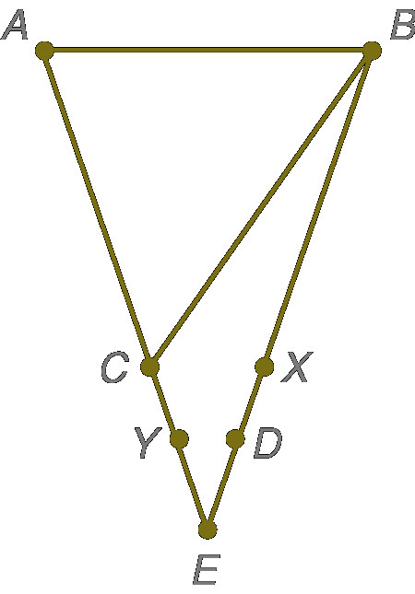
Example 2: Prove the following.

Given: AC = AB; AB = BX; CY = XD
Prove: AY = BD

Statements Reasons
1.
2.
3.
4.
5.
6.
7.

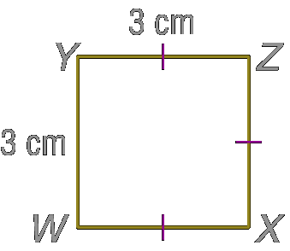
Example 3: Prove the following.

Given: WX = YZ; YZ ≅ XZ; XZ ≅ WY
Prove: WX ≅ WY

Statements Reasons
1.
2.
3.
4.
5.

Concept Summary:
Use properties of equality and congruence to write proofs involving segments

Homework: pg 104-5: 12-18, 21, 23

Preparation for Next Lesson: read Section 2-8
Section 2-8 Proving Angle Relationships

SOL: None.

Objectives:
Write proofs involving supplementary and complementary angles
Write proofs involving congruent and right angles

Vocabulary:
No new vocabulary

Key Concepts:
Postulate 2.10, Protractor Postulate: Given ray AB and a number r between 0° and 180°, there is exactly one ray with endpoint A, extending on either side of ray AB, such that the angle formed measures r°.
Postulate 2.11, Angle Addition Postulate: If R is in the interior of ∠PQS, then m∠PQR + m∠RQS = m∠PQS and if m∠PQR + m∠RQS = m∠PQS, then R is in the interior of ∠PQS.
Theorem 2.3, Supplement Theorem: If two angles form a linear pair, then they are supplementary angles.
Theorem 2.4, Complement Theorem: if the non-common sides of two adjacent angles form a right angle, then the angles are complementary angles.
Theorem 2.5, Angles supplementary to the same angle or to congruent angles are congruent.
Theorem 2.6, Angles complementary to the same angle or to congruent angles are congruent.
Theorem 2.7, Vertical Angles Theorem: if two angles are vertical angles, then they are congruent.
Theorem 2.9, Perpendicular lines intersect to form four right angles.
Theorem 2.10, All right angles are congruent.
Theorem 2.11, Perpendicular lines form congruent adjacent angles.
Theorem 2.12, If two angles are congruent and supplementary, then each angle is a right angle.
Theorem 2.13, If two congruent angles form a linear pair, then they are right angles.
Five Minute Review:

Justify each statement with a property of equality or a property of congruence.
1. If AB ≅ CD and CD ≅ EF, then AB ≅ EF.
2. RS ≅ RS
3. If H is between G and I, then GH + HI = GI.
State a conclusion that can be drawn from the statements given using the property indicated.
4. W is between X and Z; Segment Addition Postulate
5. LM ≅ NO and NO ≅ PQ; Transitive Property of Congruence
6. Which statement is true, given that K is between J and L?
a. JK + KL = JL b. JL + LK = JK c. LJ + JK = LK d. JK ≅ KL
Example 1: If ∠1 and ∠2 form a linear pair, and m∠2 = 166°, find m∠1.

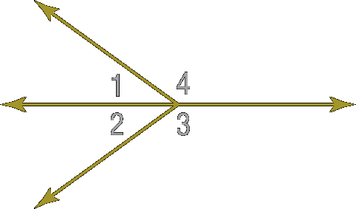
Example 2:

Given: ∠1 and ∠4 form a linear pair
m∠3 + m∠1 = 180°
Prove: ∠3 ≅ ∠4

Statements Reasons
1.
2.
3.
4.
5.
6.
7.

Example 3:
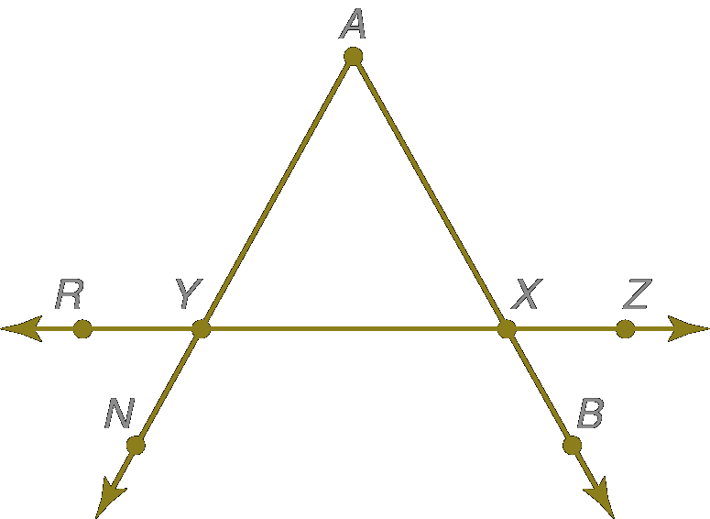
Given: ∠NYR and ∠RYA form a linear pair,
∠AXY and ∠AXZ form a linear pair,
∠RYA ≅ ∠AXZ.
Prove: ∠RYN ≅ ∠AXY

Statements Reasons
1.
2.
3.
4.
5.
6.

Concept Summary:
Properties of equality and congruence can be applied to angle relationships

Homework: pg 112-3: 16-23, 27-32, 41

Preparation for Next Lesson: Review Chapter 2

